User Interface

**Fitness Enthusiast – Sarah**

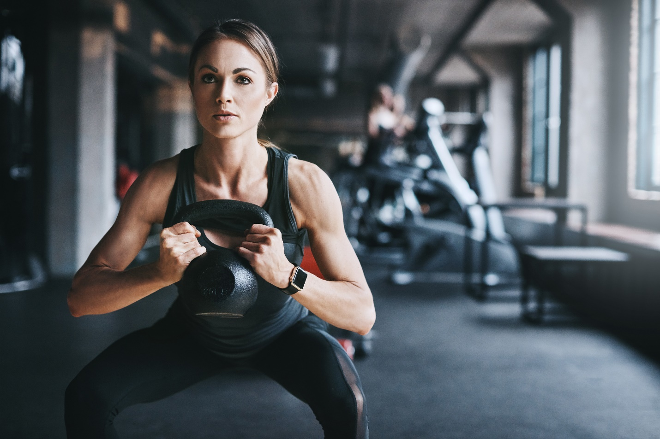

**Background:**

Sarah is a 28-year-old marketing professional who has been passionate about fitness for several years. She has experience with weightlifting, cardio, and various workout routines.

**Demographics:**

Age: 28

Occupation: Marketing Professional

Fitness Goals: Building muscle and staying fit.

Experience Level: Intermediate

**Needs and Goals:**

Sarah is looking for an application that can accurately track her workouts, including weightlifting and cardio.

She values a variety of workout routines and seeks guidance to maintain her fitness progress.

Sarah wants nutritional guidance to complement her workouts, with a focus on muscle gain and overall health.

**Beginner-David**



**Background:**

David is a 35-year-old software developer who is new to the world of fitness. He's concerned about his health and wants to start a fitness journey to get into better shape and improve his overall well-being.

**Demographics:**

Age: 35

Occupation: Software Developer

Fitness Goals: Improved health

Experience Level: Novice

Needs and Goals:

David needs an application with a straightforward and user-friendly interface.

He's looking for guidance to start a fitness journey, with beginner-friendly workout routines.

David wants a simple way to track his meals and make healthier dietary choices.

**Health-Conscious User – Maria**



**Background:**

Maria is a 42-year-old homemaker who is dedicated to maintaining a healthy lifestyle. She is not an exercise enthusiast but values regular physical activity and balanced nutrition for her and her family.

**Demographics:**

Age: 42

Occupation: Homemaker

Fitness Goals: Maintaining a healthy lifestyle.

Experience Level: Occasional exercise

**Needs and Goals**:

Maria wants a user-friendly application with a clean and simple dashboard.

While she doesn't focus on intense workouts, she is interested in basic fitness tracking to monitor her overall health.

Maria is looking for an easy way to track her meals with an emphasis on balanced and health-conscious nutrition.